1. Create a “Deloitte” User using SQL PLUS.

Create user Deloitte identified by deloitte;

1. Change the password of “Deloitte” user to new password.

Alter user Deloitte identified by new_pass;

1. Create a schema in the “Deloitte” user using Worker.sql, Bonus.sql and Title.sql file in SQL Developer.

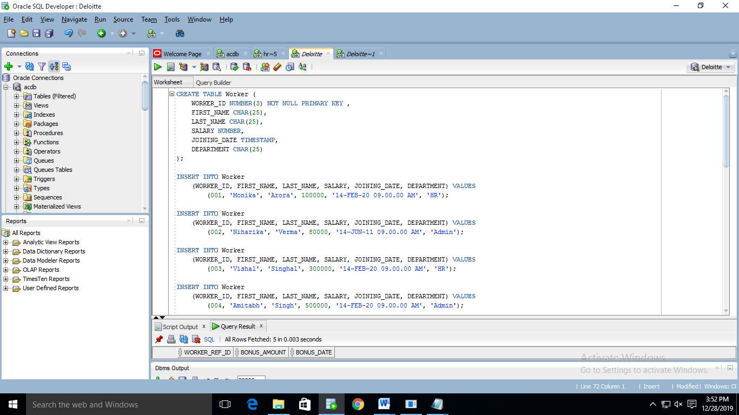

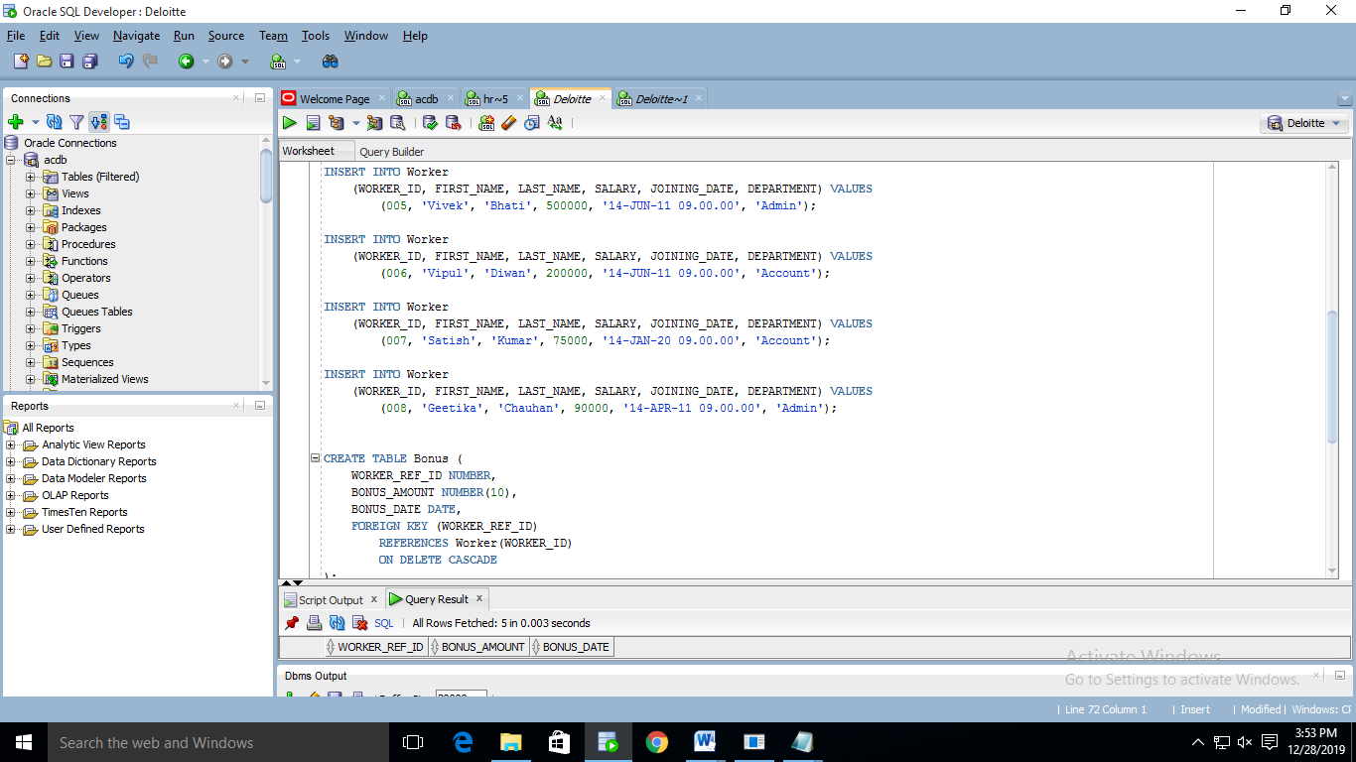

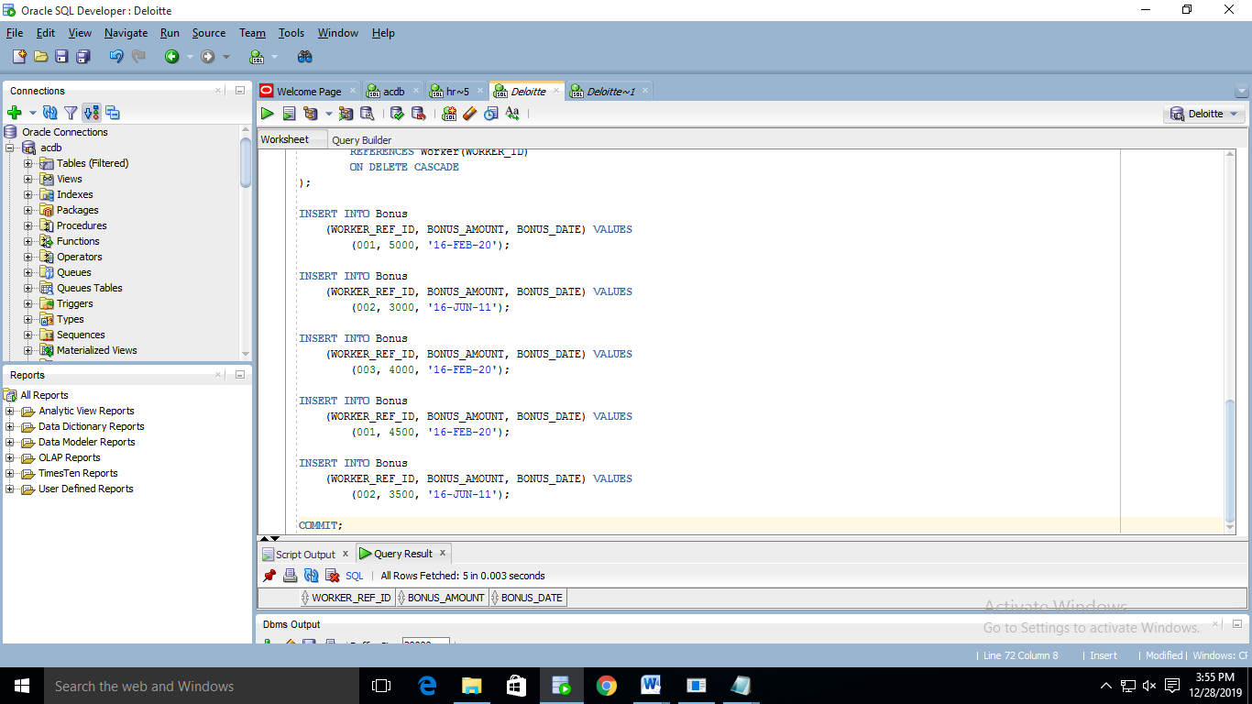

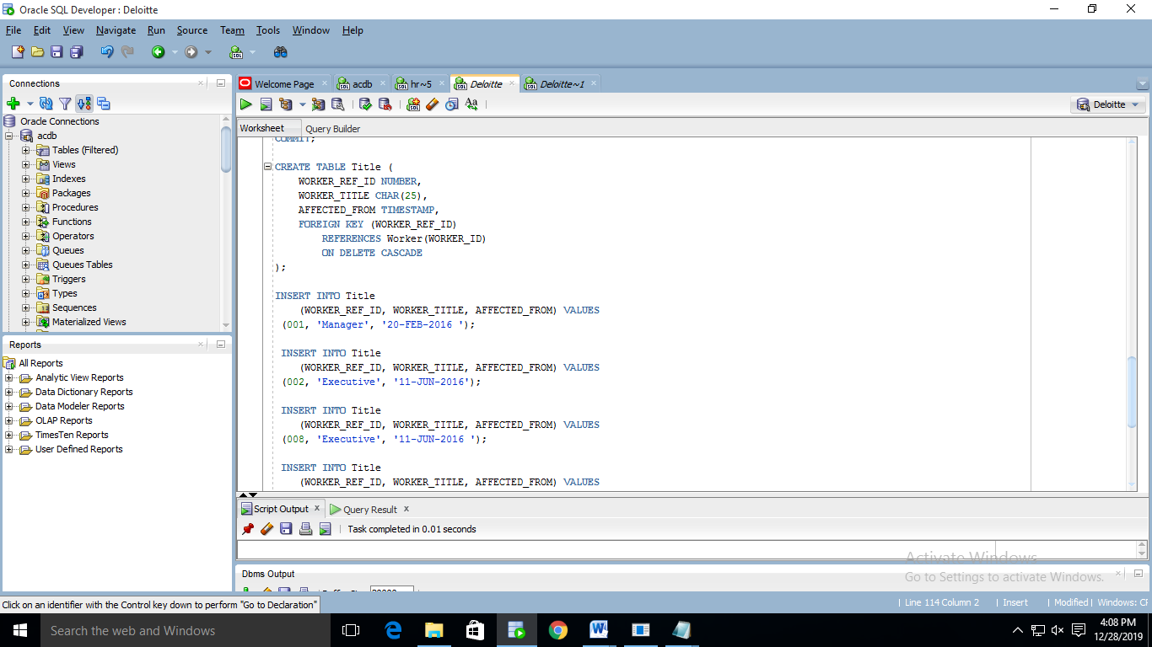

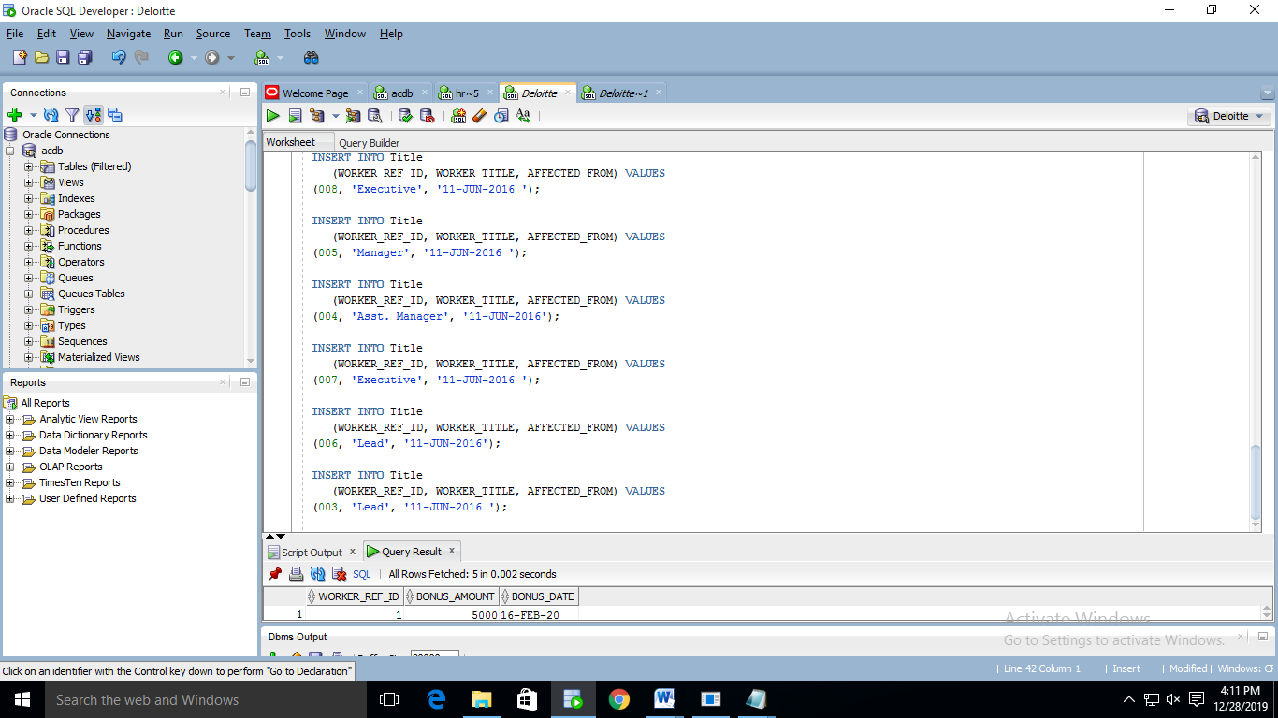

1. Write An SQL Query To Fetch “FIRST_NAME” From Worker Table Using The Alias Name As <WORKER_NAME>.

SELECT FIRST_NAME WORKER_NAME

FROM WORKER;

1. Write An SQL Query To Fetch “FIRST_NAME” From Worker Table In Upper Case.

SELECT UPPER(FIRST_NAME) WORKER_NAME

FROM WORKER;

1. Write An SQL Query To Fetch Unique Values Of DEPARTMENT From Worker Table.

SELECT DISTINCT DEPARTMENT

FROM WORKER;

1. Write An SQL Query To Find The Position Of The Alphabet (‘A’) In The First Name Column ‘Amitabh’ From Worker Table.

SELECT INSTR(FIRST_NAME,'A')

FROM WORKER;

--WHERE UPPER(FIRST_NAME) = 'AMITABH';

1. Write An SQL Query To Print The First Three Characters Of  FIRST_NAME From Worker Table.

SELECT SUBSTR(FIRST_NAME,1,3)

FROM WORKER;

1. Write An SQL Query To Print The FIRST_NAME From Worker Table After Removing White Spaces From The Right Side.

SELECT RTRIM(FIRST_NAME)

FROM WORKER;

1. Write An SQL Query To Print The DEPARTMENT From Worker Table After Removing White Spaces From The Left Side.

SELECT LTRIM(DEPARTMENT)

FROM WORKER;

1. Write An SQL Query That Fetches The Unique Values Of DEPARTMENT From Worker Table And Prints Its Length.

SELECT DISTINCT DEPARTMENT, LENGTH(TRIM(DEPARTMENT))

FROM WORKER;

1. Write An SQL Query To Print The FIRST_NAME From Worker Table After Replacing ‘A’ With ‘a’.

SELECT REPLACE(FIRST_NAME,'A','a')

FROM WORKER;

1. Write An SQL Query To Print The FIRST_NAME And LAST_NAME From Worker Table Into A Single Column COMPLETE_NAME. A Space Char Should Separate Them.

SELECT TRIM(FIRST_NAME)||' '||TRIM(LAST_NAME) FULL_NAME

FROM WORKER;

1. Write An SQL Query To Print All Worker Details From The Worker Table Order By FIRST_NAME Ascending.

SELECT *

FROM WORKER

ORDER BY FIRST_NAME;

1. Write An SQL Query To Print All Worker Details From The Worker Table Order By FIRST_NAME Ascending And DEPARTMENT Descending.

SELECT *

FROM WORKER

ORDER BY FIRST_NAME ASC, DEPARTMENT DESC;

1. Write An SQL Query To Print Details For Workers With The First Name As “Vipul” And “Satish” From Worker Table.

SELECT *

FROM WORKER

WHERE UPPER(FIRST_NAME) IN ('VIPUL','SATISH');

1. Write An SQL Query To Print Details Of Workers Excluding First Names, “Vipul” And “Satish” From Worker Table.

SELECT *

FROM WORKER

WHERE UPPER(FIRST_NAME) NOT IN ('VIPUL','SATISH');

1. Write An SQL Query To Print Details Of Workers With DEPARTMENT Name As “Admin”.

SELECT *

FROM WORKER

WHERE UPPER(DEPARTMENT) = 'ADMIN';

1. Write An SQL Query To Print Details Of The Workers Whose FIRST_NAME Contains ‘A’.

SELECT *

FROM WORKER

WHERE UPPER(FIRST_NAME) LIKE '%A%';

1. Write An SQL Query To Print Details Of The Workers Whose FIRST_NAME Ends With ‘A’.

SELECT *

FROM WORKER

WHERE TRIM(UPPER(FIRST_NAME)) LIKE '%A';

1. Write An SQL Query To Print Details Of The Workers Whose FIRST_NAME Ends With ‘H’ And Contains Six Alphabets.

SELECT *

FROM WORKER

WHERE TRIM(UPPER(FIRST_NAME)) LIKE '%H'

AND LENGTH(TRIM(FIRST_NAME)) = 6;

HR Schema.

----------------

1. Start the executable section with the BEGIN keyword and include a SELECT statement to retrieve the maximum department_id from the departments table.

SET SERVEROUTPUT ON;

DECLARE

v_max_dep_id TBLDEPARTMENTS.DEPARTMENT_ID%TYPE;

BEGIN

SELECT MAX(DEPARTMENT_ID)

INTO v_max_dep_id

FROM TBLDEPARTMENTS;

DBMS_OUTPUT.PUT_LINE('Max department id: '||v_max_dep_id);

END;

1. Write a PL/SQL block to show a reserved word can be used as a user-define identifier.

SET SERVEROUTPUT ON;

DECLARE

"CASE" NUMBER := 10;

BEGIN

DBMS_OUTPUT.PUT_LINE('Value of "CASE" : '||"CASE");

END;

1. Write PL/SQL blocks to show the scope and visibility of local and global identifiers.

SET SERVEROUTPUT ON;

DECLARE

v_num NUMBER := 10;

BEGIN

DBMS_OUTPUT.PUT_LINE('Value of v_num (before the nested block): '||v_num);

DECLARE

v_num NUMBER := 200;

BEGIN

DBMS_OUTPUT.PUT_LINE('Value of v_num (inside nested block - local): '||v_num);

END;

DBMS_OUTPUT.PUT_LINE('Value of v_num (after the nested block): '||v_num);

END;

1. Write a PL/SQL block to adjust the salary of the employee whose ID 122.

SET SERVEROUTPUT ON;

DECLARE

v_salary NUMBER;

v_new_salary NUMBER;

BEGIN

SELECT SALARY

INTO v_salary

FROM TBLEMPLOYEES

WHERE EMPLOYEE_ID = &122;

v_new_salary := v_salary*10 - 300;

DBMS_OUTPUT.PUT_LINE('Original salary : '||v_salary);

DBMS_OUTPUT.PUT_LINE('Updated salary : '||v_new_salary);

END;